Design 1: Login (top left)/create (bottom left) account page and success messages (right)

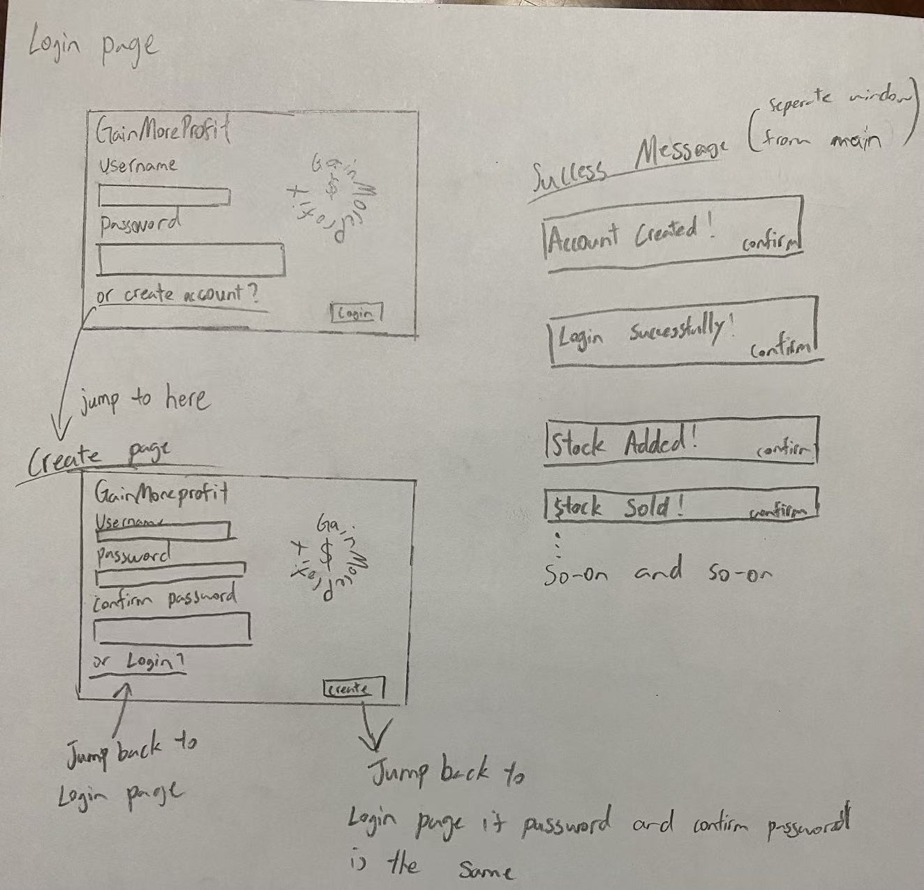

Design(s) 2: Input validations

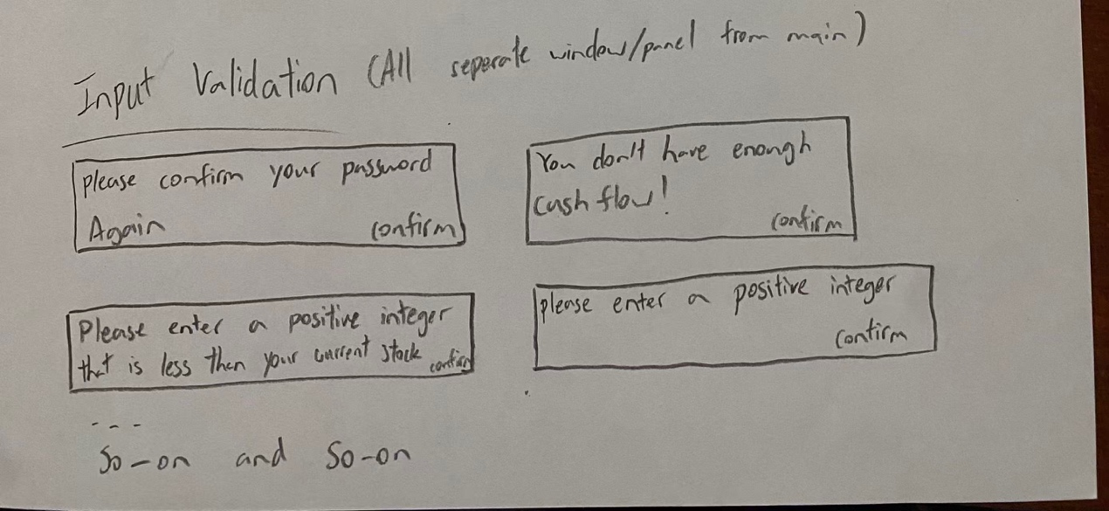

Design 3: Dashboard

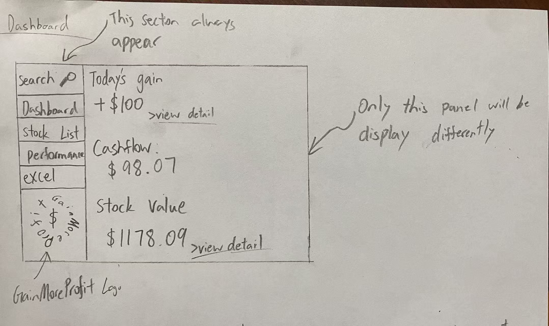

Design 4: Stock searching (left when nothing is getting inputted, right when input of name or code is entered)

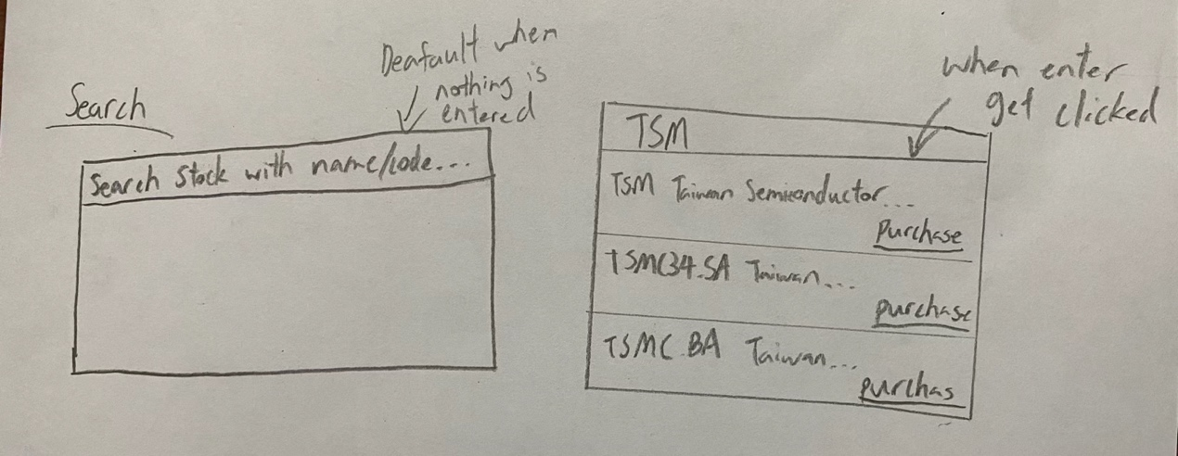

Design 5: Purchase window including viewed only elements (stock code, cash flow, price of stock(s)), and input of number of stock(s) purchasing.

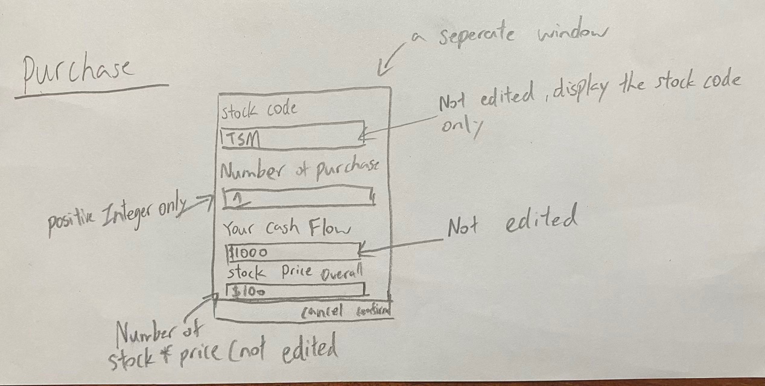

Design 5: My stock List

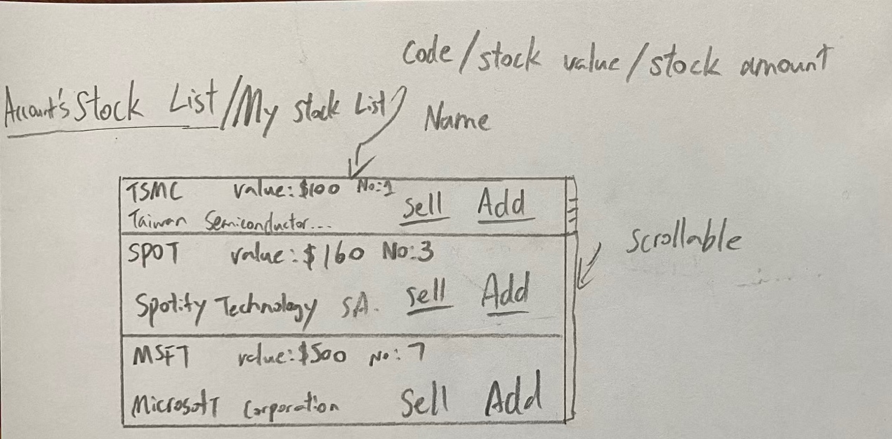

Design(s) 6: Adding (top)/Selling (middle right) window of stocks in the list in Design 5 and confirming message of general stocks (bottom left) and stocks that are decaying or growing for at least 3 days (bottom right)

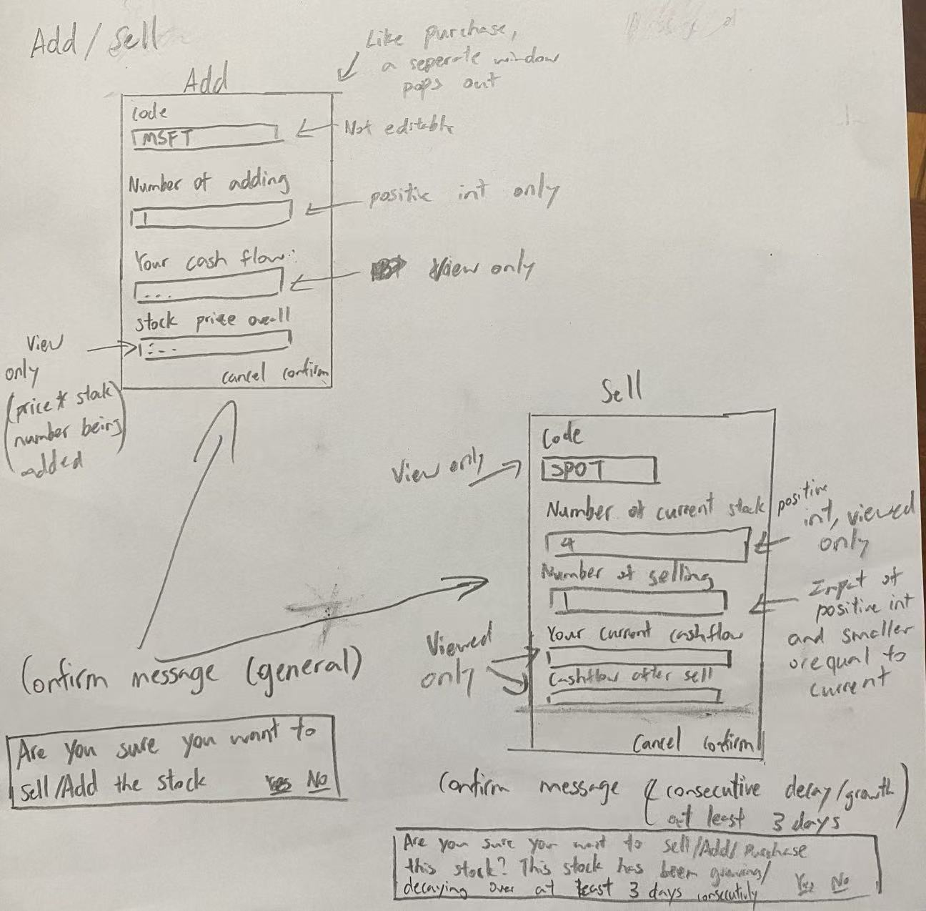

Design 6: Account overall performance with graphic display

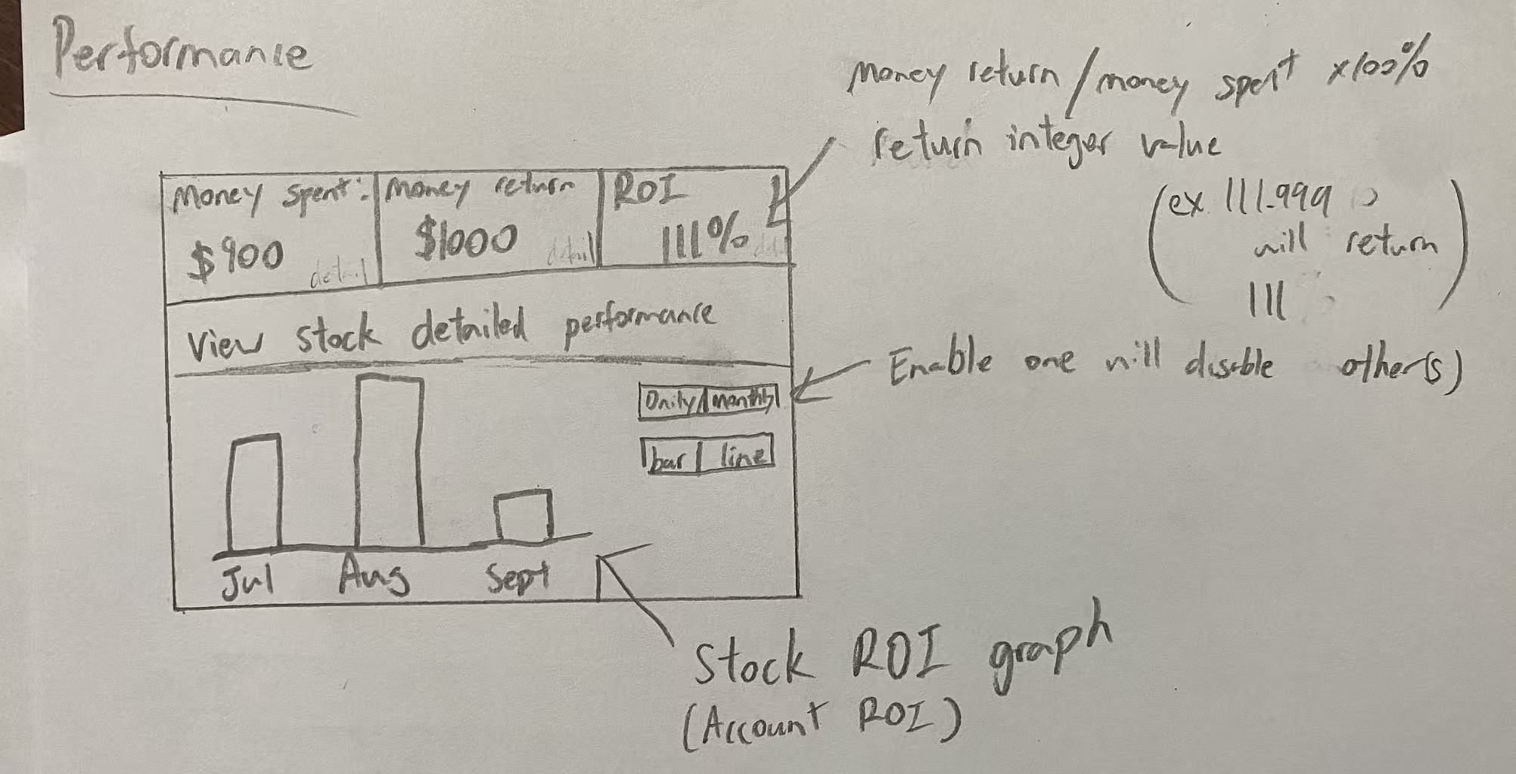

Design(s) 6: stock detailed performance of table format (top), and excel spreadsheet format being downloaded (bottom).

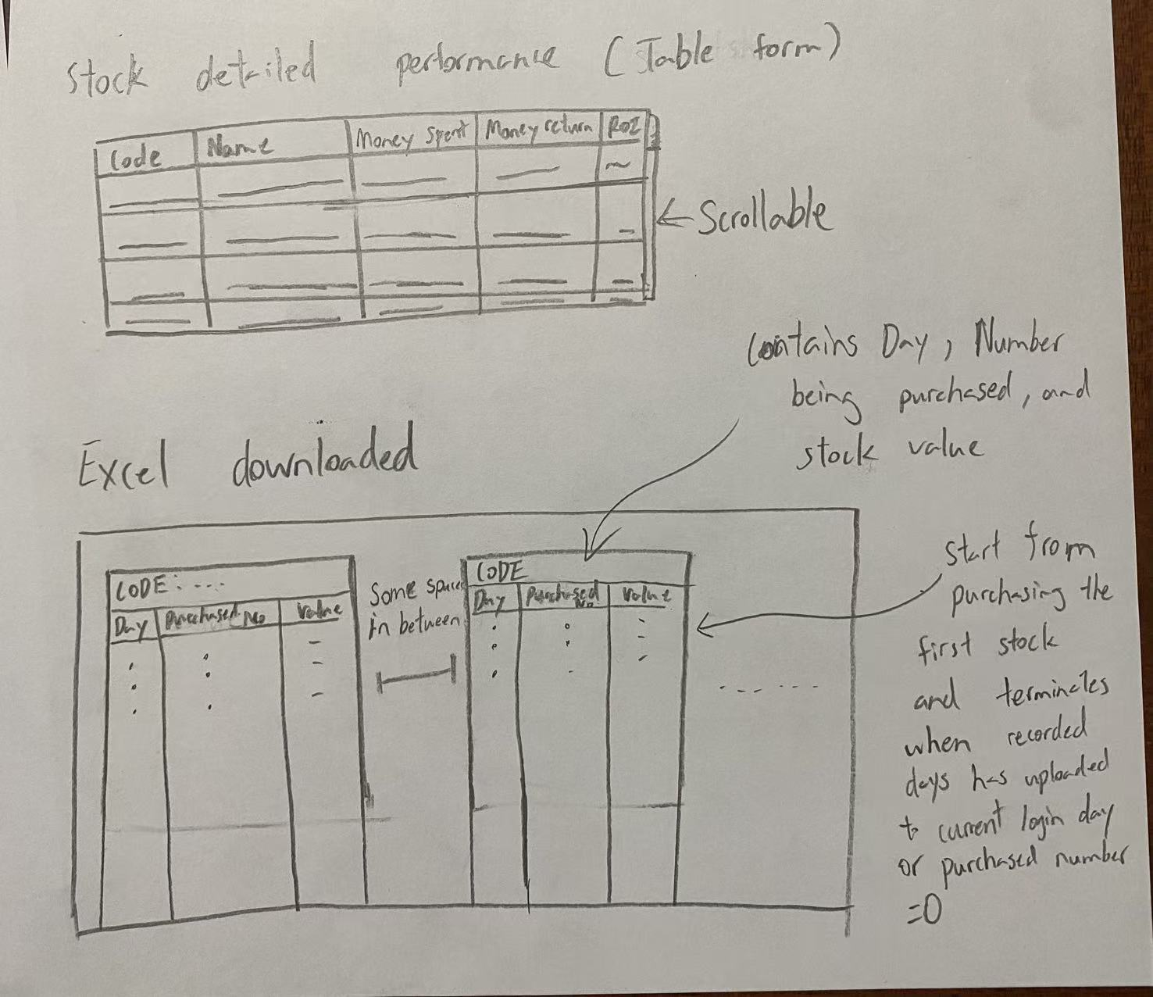

Flowchart 1: Login/create account

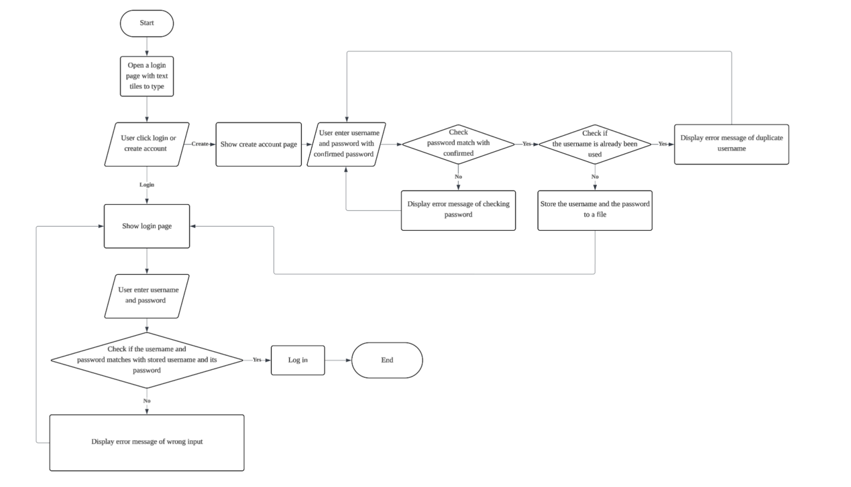

Flowchart 2: Adding/ Selling stocks in My stock list section

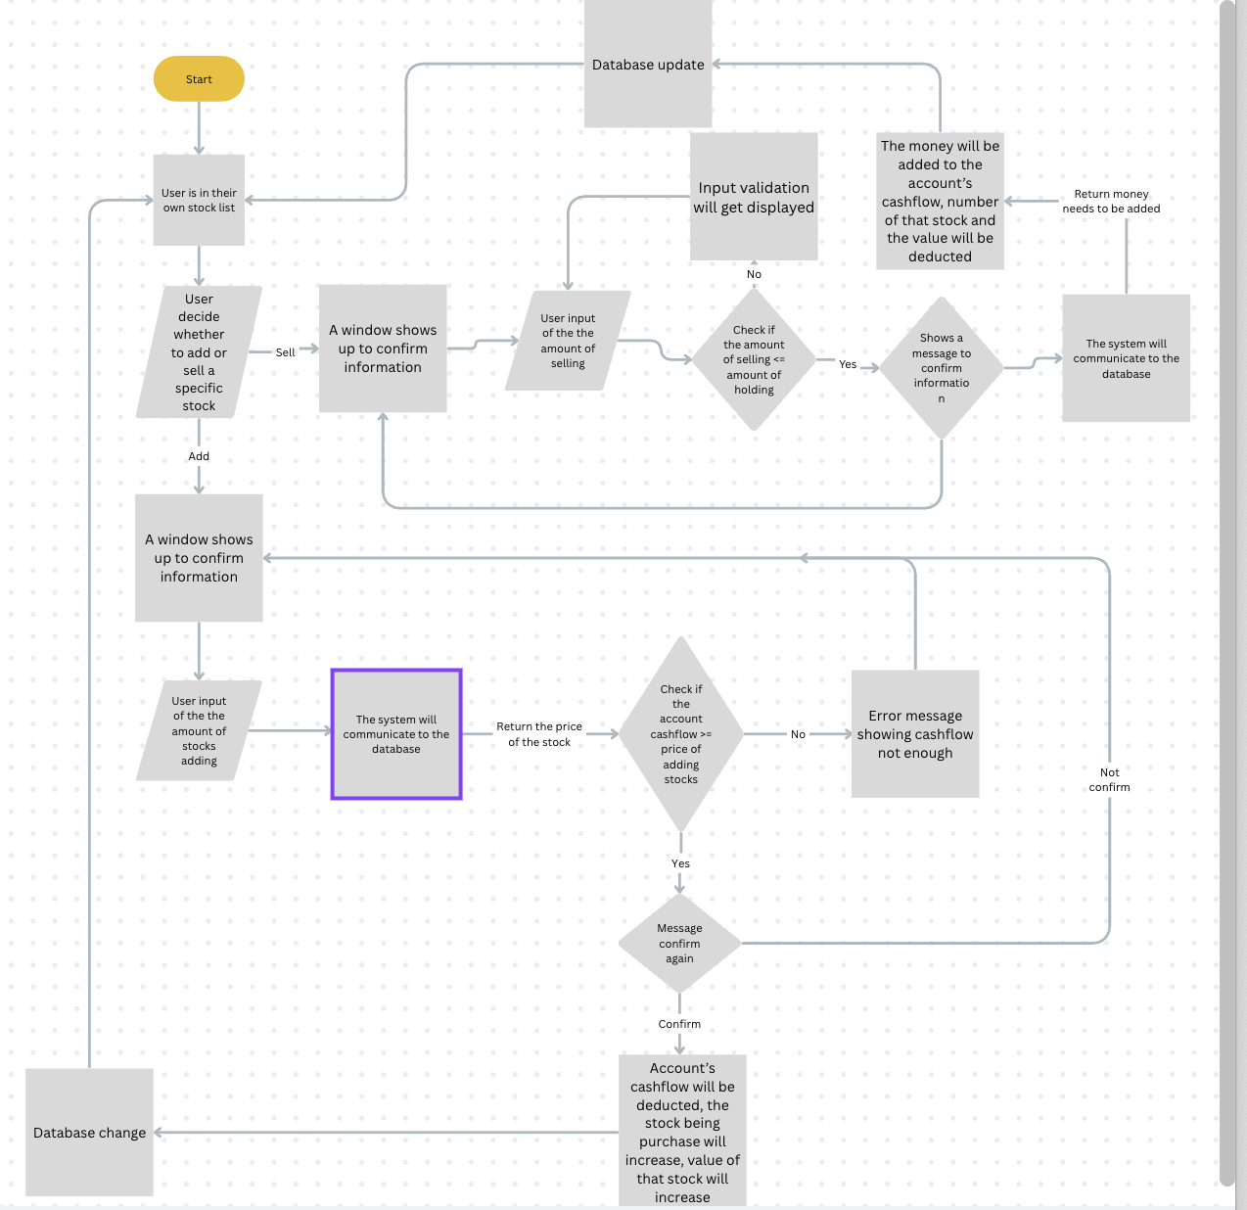

Flowchart 3: Stock price & value update

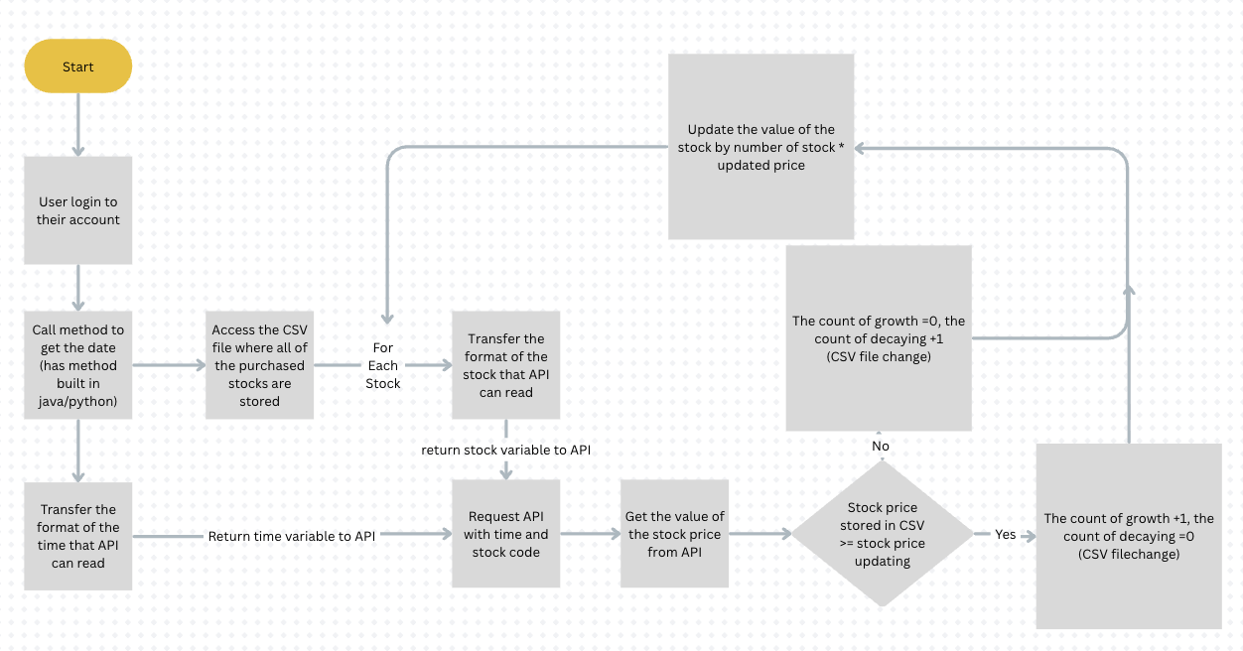

UML diagram 1: Relationship between account, stock list, and individual stock

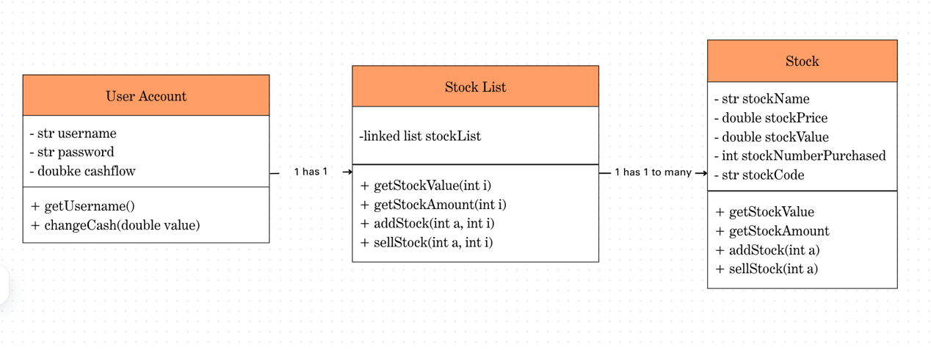

UML diagram 2: The relationship of stock API

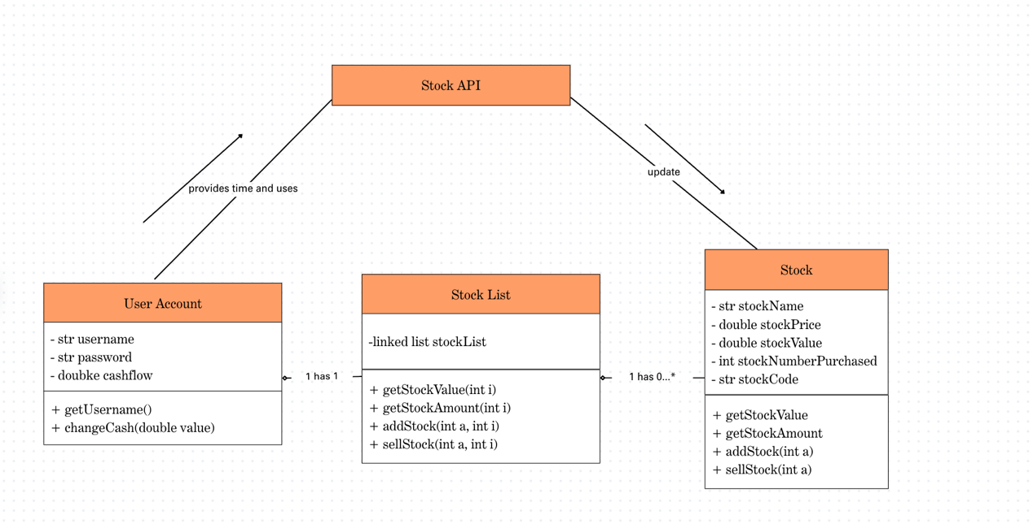

Record of Tasks

|  |  |  |  |  |  |
| --- | --- | --- | --- | --- | --- |
| Task Number | Planned action | Planned outcome | Time estimated | Target completion date | Criterion |
| 1 | Initial conference of idea | Meet with client to discuss about the blueprint of the project | 30 minutes | 01/07/2025 | A |
| 2 | Choose tech stack | Chosen programming languages for frontend +backend and API framework | A week | 08/07/2025 | A |
| 3 | Discuss detail with client | Discuss about detailed that client want offline | 30 minutes | 22/08/2025 | A |
| 4 | Write down success criteria | Outline success criteria for the project | 2 days | 07/09/2025 | A |
| 5 | Familiarize programming language (Python, Java Spring boot) | Able to use those programming languages for the project | A month (start from August) | 15/09/2025 | B |
| 6 | Familiarize tech stack feature (web scrapping, API communication) | Able to use those tech stack for the project | 2 months  (start from August) | 05/10/2025 | B |
| 7 | Write testing plan | Make a list of tests needed for the project to meet the success criteria | 2 hours | 06/10/2025 | B |
| 8 | Design Simple GUI | Make a simple blueprint of GUI needed in the application | 3 hours | 07/10/2025 | B |
| 9 | Create UML Diagram | Created diagrams for the relationship between different component within the application | 3~4hours | 08/10/2025 | B |
| 10 | Access and store stock using API and web scrapping | make a way for an application to communicate with the stock databases and get stock data for each day | A week | 20/10/2025 | C |
| 11 | Develop a complete authentication system | Ensure that user can login and create account using the application | 3 days | 26/10/2025 | C |
| 12 | Develop Search and add/delete system of stocks | Complete the search system with addition and deletion into user’s stock list | 8 days | 02/11/2025 | C |
| 13 | Develop profit/loss calculation system | The application can correctly record the overall/daily profit and loss on the user’s stocks | 5 days | 16/11/2025 |  |
| 14 | Develop performance-graph system and excel execute | The application can correctly record each day/month performance on visual graphs or excel spreadsheet | 5 days | 21/11/2025 | C |
| 15 | Create estimation algorithms for stock value (not sure if needed) | The application can give an estimation on the changes of the value of stock and suggest the user to sell or keep the stock | 1.5 weeks | 07/12/2025 | C |
| 16 | Compile the features into prototype | A prototype is created and ready to test features applied on it | 2 weeks | 21/12/2025 |  |
| 17 | Gain feedback from client | Meet with client again with the prototype and discuss about improvements or details need to be added | 1 hour | 1/1/2026 |  |
| 18 |  |  |  |  |  |